**Kura Labs - Cohort 3**

**Deployment 3 Documentation**

***Author: Mike Major***

**Creating a Jenkins CI/CD environment**

**Creating Initial Jenkins Server on EC2**

* **If you already have a VPC, please skip the steps below**
* **Log into AWS via the Console. Make sure to set your regions and availability zones** 
  + **Use Ubuntu and ensure ports 22, 8080 are open in your security groups for SSH (22) and Jenkins (8080)**
* **Assign a keypair to your EC2.** 
  + **Make sure your keypair is correctly located on the server you are attempting to connect.**
* **After the EC2 has been created, install Jenkins utilizing the code block below**

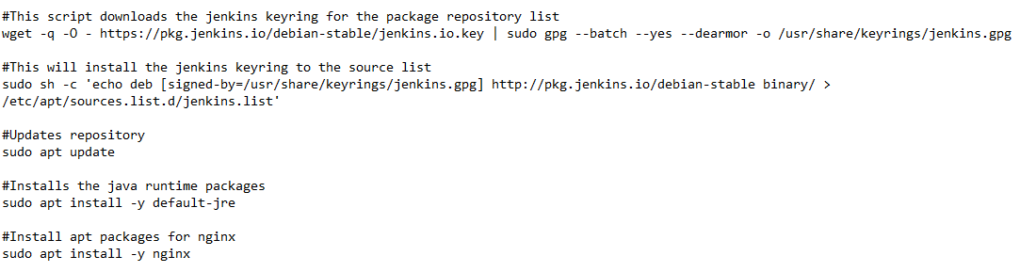

* **It is recommended that after installing nginx, you restart the server.**
* **To log into your Jenkins server, enter your public facing ip alongside port 8080 to connect.**
* **Then, use the “cat” command to view your secret password.**
  + **“sudo cat /var/lib/jenkins/secrets/initialAdminPassword”**

**Configure and connect a Jenkins agent to Jenkins**

* **In the first EC2 created in VPC1, connect to Jenkins by using your public facing ip address and port. A jenkins agent is used to monitor**
* **Connect to the Jenkins server and select the Build Executor Status**

**Create VPC in a Public Subnet**

* **Within your AWS console, go the VPC menu and click Create VPC**
* **Select VPC Only**
* **Set your IPv4 CIDR block to manual and enter your preferred CIDR block**
  + **Example 172.25.0.0/16**
    - **For questions on CIDR blocks see** [**here**](https://docs.aws.amazon.com/vpc/latest/userguide/configure-your-vpc.html)**.**
* **Then Click Create VPC**
* **After your VPC has been created, click on Subnets**
* **Click Create Subnet**
  + **Make sure to properly plan and allocate your IP’s for your CIDR block. For instance, if you used a /16 CIDR block, you would use a /18 that would afford you 4 subnets.**
* **A routing table will be created by default for you in AWS**
* **To give your subnet public facing internet access, you will need to attach an internet gateway**
* **Click Internet Gateway, then under actions click attach to the VPC you just created.**

**Connect Jenkins to GitHub**

* **During your initial setup of Jenkins you will need to create an admin account**
* **Then, ensure all of the recommended plugins are installed before proceeding**